Priory Surgery Practice Profile
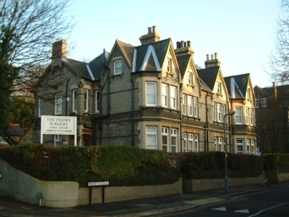
Contact: Philippa Constable
Priory Surgery, 24-26 Priory Ave, High Wycombe, Bucks HP13 6SH
Tel: 01494 686403 Email: p.constable@nhs.net

Practice Area
High Wycombe is a town situated in the heart of the Chiltern Hills with a population of 120,256 (Census 2011). Traditionally a furniture making town, now a market town with light industry/service industries, surrounded by countryside with many Areas of Outstanding Natural Beauty, extensive beech woods and the Hambleden Valley.

There is easy access to the M40, M25 and M4 motorways. London is 32 miles away and served by the Chiltern Line Railways. There are excellent Primary and Secondary schools. Wycombe retains its’ Grammar Schools. Wycombe hosts the main campus for Buckinghamshire New University.

Local attractions include Hughenden Manor (Disraeli), West Wycombe caves and park, chair museum, gliding/small aircraft/helicopter flights at Wycombe Air Park, and Wycombe Wanderers Football Club. The Eden Centre has an array of quality shops, restaurants, a bowling ally and cinema.

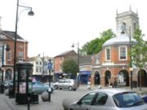
The Practice
Priory Surgery is the longest established practice in the town. The surgery is a 3 storey converted Victorian building owned by the Partners, in the heart of the town. It serves a practice population of 11,000 in a suburban setting with a few outlying villages.

We use EmisWeb as our Practice IT system.

We are constantly looking to improve and welcome feedback from staff and patients alike.

Partners

Dr Harjot Bal
Dr Parminder Saini
Dr Jenna Todd
Dr Amanda Bartlett

We have a team of a Practice Manager, 5 salaried GP’s, 3 Practice Nurses, 1 Paramedic, 3 Pharmacists, and two pharmacy technicians, supported by a committed experienced team of reception and administration staff.

Clinics comprise Diabetes, Child Health Surveillance, Health Checks, CHD/smoking, COPD/Asthma, Family Planning.
Outside commitments include additional support for Catherine Court Nursing Home, Ryeview Care Home, Little Oaks Residential Home, Maria Residential Home, Whiteleaf Support (LD) residential and Godstowe School.

Practice Ethos
We are a busy, hard working team providing a full range of services with high quality care encompassing traditional family medicine. We retain our sense of humour and staff enjoy our working environment. High Wycombe is an excellent place to live and work.

