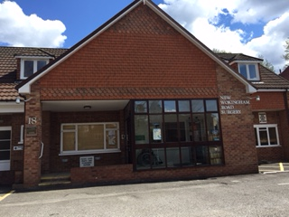

GP Partner Opportunity
New Wokingham Road Surgery, Crowthorne, Berkshire
Are you looking for a supportive, forward-thinking practice where you can make a real difference?
We’re excited to offer an opportunity for a committed GP Partner to join our friendly team in beautiful Berkshire.
About Us

- Patient List: 9800 patients (with long-term growth 4-5% annually)
- Partner-owned practice with a strong reputation for high-quality care and consistently excellent GP Patient Survey results
- Team: 3 Partners, 1 part time salaried GP, plus ANP, Paramedic, Clinical Pharmacists, First Contact Physio, Phlebotomy and more
- We value outstanding clinical care and a sensible work-life balance

Due to an upcoming retirement, this is a fantastic chance to become part of an established, thriving partnership.
The Role

- Flexible 6 sessions per week – we’re happy to accommodation your needs and special interests
- Consultations: Face to face and telephone
- Duty Doctor: Supportive rota system with digital triage (Accurx Triage)
- Monthly business and clinical meetings
- You’ll hold your own patient list
Why Join Us?

- Highly rated for patient satisfaction
- Supportive, easy-going clinical team
- Opportunities to develop special interests
- Sustainable work-life balance

Remuneration

- Competitive monthly drawings
- 6 weeks annual leave plus 1 week study leave

About Crowthorne & Berkshire

Crowthorne is a vibrant village in Berkshire, offering the perfect blend of countryside charm and excellent transport links. Located near Wokingham and Bracknell, and just a short drive from Reading, the area boasts:

- Great schools and family-friendly amenities
- Beautiful green spaces including Swinley Forest and Wellington College grounds
- Easy access to London (under an hour by train) and Heathrow Airport
- A welcoming community with shops, cafes and leisure facilities

Interested?

We’d love to hear from you!

For an informal chat or to arrange a visit, please contact: Jane Kirkwood (Practice Manager) at jane.kirkwood1@nhs.net

Please send your CV and a covering letter by 13 February 2026

