

GROVELANDS MEDICAL CENTRE

701 Oxford Road, Reading, RG30 1HG

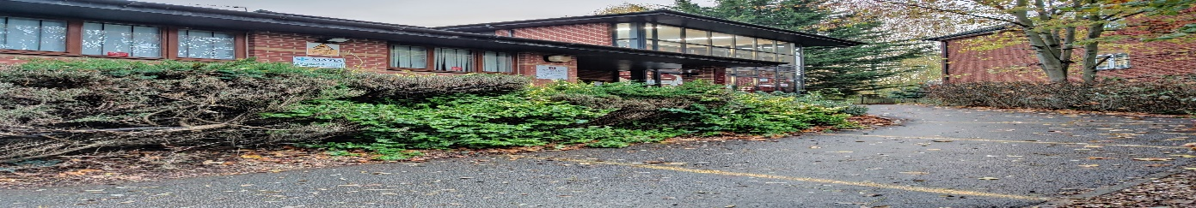

**Vacancy for a Practice Paramedic**

**We are looking to recruit a Practice Paramedic to join our friendly team, full time post (37.5 hours a week) Mon - Friday, some flexibility on hours.**

**The successful candidate will be required to work independently, within the scope of their professional boundaries, to assess and manage patients. The role will involve visiting patients at home, with acute presentations, and ongoing assessments of patients with chronic disease and end-of-life care.**

**We are developing the role of paramedics within the surgery, and we are keen to hear from individuals who may have done additional training, including minor illness and prescribing, who may be able to assist with triage and minor illness clinics within the surgery.**

**You will need to demonstrate safe clinical decision-making and expert care, including assessment and diagnostic skills. Patients requiring a referral to secondary care should be discussed with their own GP or the Duty Doctor. You will be working alongside the MDT team within the practice.**

**Alongside the Duty Doctor, you will provide a first point of contact within the Practice for patients presenting with undifferentiated, undiagnosed problems, making use of skills in history taking, physical examination, problem-solving, and clinical decision-making to establish a diagnosis and management plan.**

* **Provide assessment, treatment, and diagnosis at the point of first contact, by attending to patients in a variety of clinical or non-clinical settings according to the patient’s needs.**
* **Undertake home visits, in accordance with the relevant protocols.**
* **Make professionally autonomous decisions for which you are accountable.**
* **Refer patients to an alternative care setting or treat and discharge as appropriate.**
* **Instigate necessary invasive/non-invasive diagnostic tests/investigations and interpret findings/reports.**
* **Ensure that professional standards are maintained and within the guidance issued by the DoH (Department of Health), the HCPC (Health and Care Professions Council), and the College of Paramedics (COP).**
* **Ensure that there is a robust system in place for maintaining clinical governance.**
* **Work with multi-disciplinary teams within the Practice and across the broader healthcare community to promote integrated and seamless pathways of care.**
* **Contribute to the Practice achieving its quality targets to sustain the high standards of patient care and service delivery.**

**Overview of Our Organisation**

**You will be joining our friendly, dynamic team of 7 Partners from diverse backgrounds, and 5 Salaried GPs, approximately 14,000 patients, we are an Emis Web practice with a full range of enhanced services.**

**Our high-performing team includes Nursing staff, Paramedics, Pharmacists, Pharmacy Technician, Care Co Ordinator, Social Prescriber, and First Contact Physiotherapist. You will also be supported by our excellent reception and admin team. Consistently high QOF achieving surgery.**

**We encourage daily morning coffee breaks to allow for catch ups at 11am.**

**Benefits included NHS Pension Scheme and on-site parking.**

**Any questions and informal visit welcomed, please contact our Deputy Practice Manager.**

**Please forward CV to grovelands.admin@nhs.net**