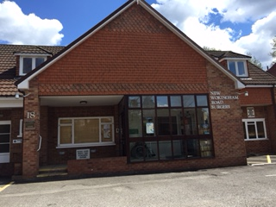
New Wokingham Road Surgery
Crowthorne, Berkshire RG45 6JL

Part-time Practice Nurse or Nursing Associate
2 days a week – ideally Wednesdays & Thursdays

We’re expanding our nursing team and are looking for an enthusiastic Practice Nurse or Nursing Associate to join us on a part-time basis (2 days per week).
About Us

Our thriving practice in Crowthorne cares for around 9,700 patients and is home to a supportive, friendly team. We have:

- 3 GP partners and 1 salaried GP
- Advanced Nurse Practitioners, Paramedic, Practice Nurses, Assistant Practitioner and HCA.
- Clinical Pharmacists, First Contact Physiotherapist, Social Prescriber and mental health support from MIND
- Our reception and administration teams deliver first-class service, and we pride ourselves on valuing both our staff and our patients

What We’re Looking For
Experience in:
- Wound management
- Chronic Disease Management
- Immunisations (including childhood and routine)
- Treatment room duties
- Infection Control

What We Offer

- Flexible working hours
- Pro-rata benefits: 5 weeks’ annual leave + 1 week study leave
- NHS pension contribution
- Salary based on experience

We welcome informal visits and are happy to discuss the role in more detail.

How to Apply

Please send your CV and covering letter to Jane Kirkwood, Practice Manager at jane.kirkwood1@nhs.net.

Closing Date: Friday 19 December 2025

Our organisation is committed to fairness, diversity, equity and equality of opportunity. We aim to maintain an inclusive working environment free from bias and unlawful discrimination.

https://newwokinghamroadsurgery.nhs.uk/

