“Empowering our community to achieve greater health and wellbeing"

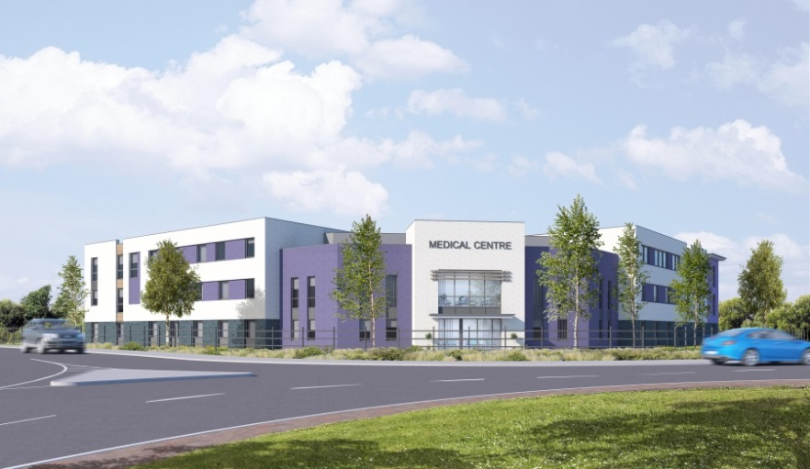

Salaried GP Vacancy

We are offering an opportunity for doctors to join our incredibly friendly team, in our brand-new purpose-built practice. As a training practice we welcome new talent to be part of the vision we have for patient and staff wellbeing through innovative ‘cluster’ working within a bespoke setting. You may want to focus on part-time clinical work and want to be somewhere with excellent mentoring, support, education, and development. We have a dedicated group of doctors for whom work life balance is crucial and who recognise and value the benefits of working in a friendly and diverse team.

Key Benefits:

- Flexible working: applications will be considered for salaried, retainer, returners and new to practice applicants. Take advantage of the option to work from home (doctors working five or more sessions have the option of working one session a week at home).
- Mentoring support: benefit from mentoring support provided by a senior GP, who will guide and mentor you as you navigate your career path.
- Support from GP Assistant: work collaboratively with a GP Assistant who will provide valuable assistance, allowing you to optimise your efficiency and effectiveness in patient care.
- Teaching opportunities: if training is your passion, we welcome trainers to get involved in teaching medical students and contribute to the education and training of the next generation of doctors.
- Dedicated admin sessions: enjoy the support of dedicated administration sessions, ensuring you can focus on delivering high-quality care to your patients; you will have one admin session for every ten sessions.
- Competitive compensation: receive a generous remuneration of £11,000 per session per annum, ensuring your skills and expertise are recognised and rewarded.
- Holiday: 32 days annual leave (pro rata).

Additional benefits:

- Friendly team and supportive environment: join our welcoming team of healthcare professionals who collaborate with not just our team, but our community through our Collaborative Practice Initiative and Friends of Berrycroft charity.
- State-of-the-art facility: work in a new purpose-built centre equipped with modern amenities. Enjoy the convenience of an onsite café and childcare providers nearby.
- Free Parking: onsite parking
- On-Site Discounts: our inhouse coffee shop, staff discount available
- NHS Pension: NHS contribution full pension in line with annual salary
- Blue Light Card Discounts: discounts available on thousands of brands and services
- Employee Forum: have your say, collaborate with our wider team.

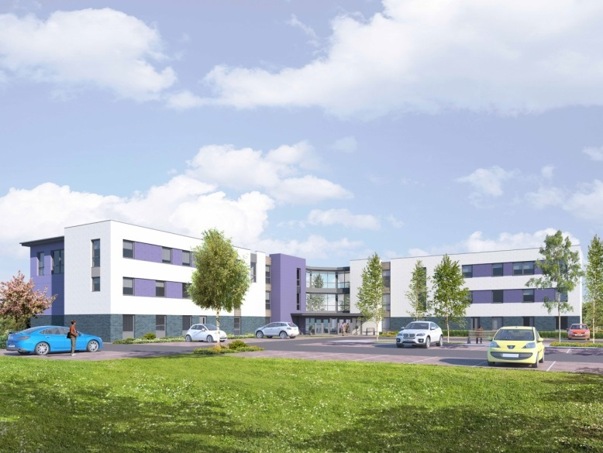

Please contact kathryn.how@nhs.net for more information, to arrange an informal visit, or for contact details of one of our salaried GPs to find out what it’s like to work for us.

