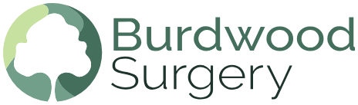
Salaried GP – Fixed Term, 12 Months
Burdwood Surgery • Thatcham • RG19 4YF
4–6 Sessions per Week
Salary: Dependent on Experience

Join Our Supportive and Forward-Thinking Team
Burdwood Surgery is delighted to invite applications for a Fixed Term Salaried GP to join our friendly, dynamic, and high-quality practice team. This is an excellent opportunity for an enthusiastic and committed GP, including newly or recently qualified GPs looking for a supportive environment to further develop their skills.

Why Join Us?

A Modern, Progressive Practice
Innovative ways of working, including:
- Cloud-based telephony
- Online and remote consultations
- Flexible home and remote working options
- EMIS clinical system supported by Anima Triage and Anima Document Management
Excellent Reputation
- CQC rated “Good” in all domains
- Top 3 practice in Berkshire West in the latest National Patient Survey (out of nearly 50 practices)
- Exemplar GP Training Practice with 2 GP registrars and medical students
- Part of the Kennet PCN
Our Team
We provide care for approximately 10,500 patients and our clinical team includes:
- 3 GP Partners
- 8 Salaried GPs
- A skilled Treatment Room team
- Paramedics supporting patient care
You’ll be joining a warm, collaborative, and highly trained multidisciplinary team.

The Role
- 4–8 sessions per week
- 12-month fixed term (at least initially)
- Working closely with our clinical, managerial, and administrative teams
- Opportunities for continued learning, development, and involvement in practice initiatives

How to Apply
Please send your CV and covering letter to: mark.foster9@nhs.net
Or contact us for an informal chat/visit
Closing Date: Monday 28th August 2026

