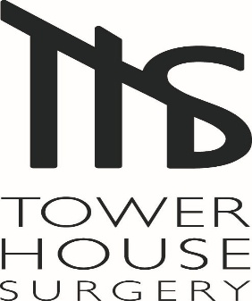
4-6 Session GP
Thursday and Friday required
Would you like to work in a multicultural town, enjoy the beautiful Chiltern Hills on your doorstep, and still be only 30 minutes from London Marylebone?
If you are a committed GP who values teamwork, high-quality care and a supportive working environment, we would be delighted to hear from you.
We are looking for a personable, highly motivated, committed GP to join our friendly practice based in High Wycombe. We are a practice of 3 partners working alongside a dynamic team of salaried GPs, paramedics, nurses, HCA’s, pharmacist and GP Assistant. On top of this we have our wider PCN attached team including pharmacists, paramedics and social prescribers to care for our young, diverse population of 10,000. We have a dedicated, supportive non-clinical admin team including clinical coders, secretaries etc.
GPs are encouraged to attend Protected Learning Time (PLT) time sessions. We hold regular Practice meetings which include safeguarding, palliative care and significant events.
We place great value on balancing clinical excellence with a healthy work-life balance. We welcome applications from both newly qualified and experienced GPs seeking 4-6 sessions per week, with flexibility around session times. Special interests are encouraged and supported.
What we offer:
- EMIS Web, Docman & AccuRx
- Considered GP Retainer Scheme
- 15-minute appointments
- GP Assistant working alongside the duty doctor
- Young, socially and ethnically diverse patient population – no nursing homes
- Excellent opportunities for career development and support for special interests
- Air-conditioned consultation rooms
- Approachable, supportive partners and a genuinely friendly team
- Salary £10,600- £11,500 per session depending on experience and responsibilities.

How to Apply
Please email your CV and a covering letter outlining your interest and suitability for the role to:
Sandy Mudhoo, Practice Business Manager: bobicb-bucks.ths.pm@nhs.net
For further information or to arrange an informal conversation or visit, please contact the Practice Business Manager or Senior Partner, Dr Sarah Annetts, via the email address above.

