Fenny Compton & Shenington Surgeries, The High Street, Fenny Compton, Southam, Warwickshire, CV47 2YG
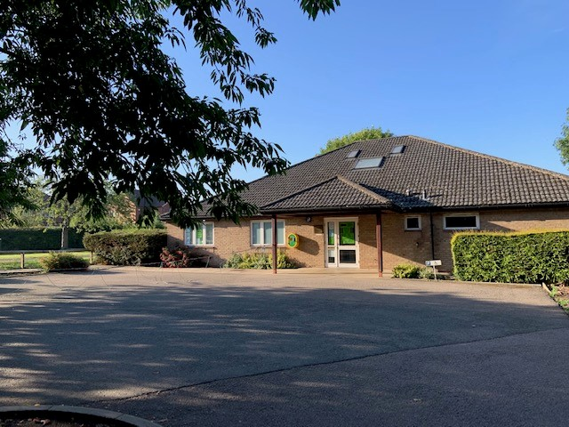
Salaried GP position – 8 sessions per week

We are seeking an enthusiastic salaried GP to join our friendly practice, starting in January 2027. The position is available due to the retirement of a long standing GP partner and we wish to give ourselves plenty of time to find the right candidate.

You will be fully supported by our multi-disciplinary team in order to provide and maintain the highest possible standard of care for our patients. We require 8 sessions per week. We are open to discussions about alternative working patterns but ideally seek 1 candidate for all 8 sessions. You will also be required to work at our branch surgery in Shenington (OX15 6NF) on a rota basis. Your contract will be based on the BMA standard contract.

A little more about us:
- 2 purpose built premises to accommodate our growing list size of approx. 5250 patients. Both sites are traditional rural dispensing practices and dispense to 98% of our population.
- We use EMIS Web, Docman and Lexacom digital dictation & AccuRx.
- We are a training practice and welcome GP registrars.
- We are exceptionally high QOF achieving, rated good by CQC and received excellent results from the recent national patient survey and FFT.
- Our supportive team is made up of 2 GP partners, 2 salaried GPs, Practice Nurse & 2 HCAs, along with a dedicated dispensary team, secretarial and reception support.
- We actively participate in our local PCN and Federation.
- Very low home visiting rates.
- No residential or nursing homes.
- Practice area consists of numerous idyllic villages in countryside close to Leamington Spa, Stratford upon Avon and Banbury - a great place to live and work.
- Easy access to motorway network via M40. Less than an hour by train to London from Banbury Station and great local schools, both primary and secondary.

We can offer a competitive salary & benefits for the right candidate. We would welcome any informal enquiries and encourage practice visits.

Further information about our practice can be found on our website at www.fennycomptonandsheningtonsurgery.nhs.uk

For further details, please contact Practice Manager, Lisa Yates on 01295 771824 or via email: lisa.yates@gp-m84009.nhs.uk.

