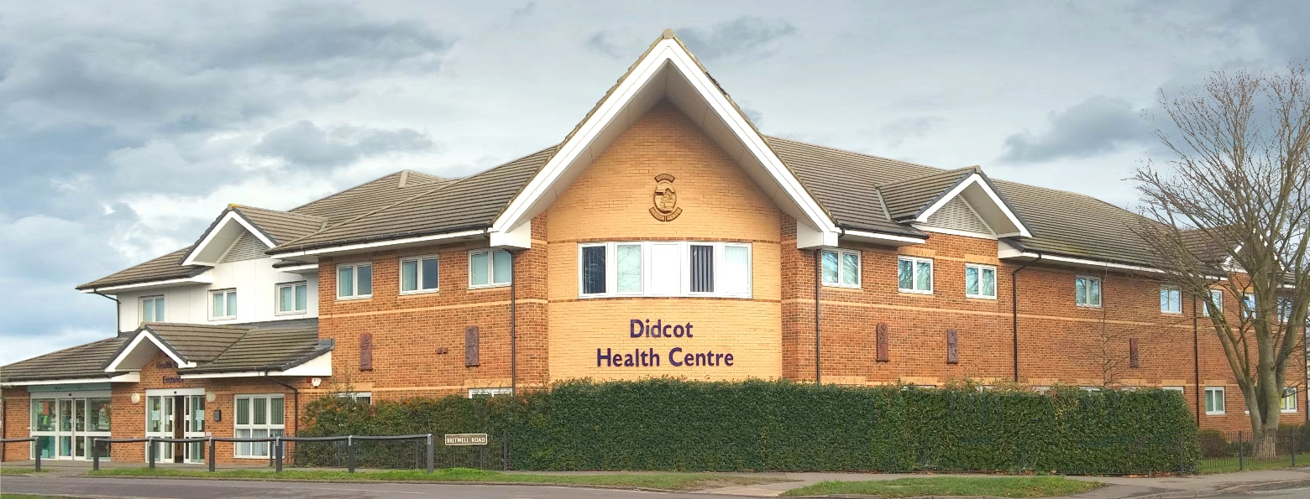
Didcot Health Centre

Salaried GP with option for Partnership, South Oxfordshire

Starting date: Negotiable

Closing date: 30 April 2024

We are looking for a GP to join our large, well-served practice for 5-8 sessions per week. We're a flexible employer, so we would be happy to talk to you about a working pattern that suits your busy life or portfolio career. As a training practice, we would also be keen to support you in developing your chosen clinical area of interest.
The position would initially be as a Salaried GP, but if you are interested in partnership, we would be happy to discuss this option.
The starting date is negotiable, and we may close the ad early if we find the right candidate.

About the job
The post covers the full range of duties and responsibilities associated with a GP working in primary care. In addition, we provide extended hours appointments on Monday and Wednesday evenings, allocated to GPs on a rota. Some of these sessions are telephone only clinics sessions that can be worked remotely.

About us
We are a well-established training practice operating from purpose-built premises close to the town centre, just a few minutes’ walk from Didcot Parkway and its excellent rail links.
In addition:
- We are a GMS 19,500 patient practice
- We are rated as Good in all areas by the CQC
- We are a team of 6 partners and 5 salaried GPs, 2 Advanced Paramedic Practitioners, 4 Practice Nurses, 4 Healthcare Assistants, a Diabetes Specialist Nurse, and a PCN team comprising a Physician Associate, First Contact Physios, Pharmacists, Counsellors, a Psychiatric Nurse, and Social Prescribers, and we have a large and very supportive non-clinical team
- We host weekly clinics for a range of counsellors, therapists, a specialist addiction service nurse, and regular outreach/community clinics from secondary care, as well as accommodating the District Nursing and Midwifery teams for Didcot
- Education sessions are programmed into clinicians' schedules
- We are proud to have been a training practice for many years, our two trainers currently working with one ST3 and an ST2
- We recognise people's desire for personal development and will support you in developing expertise in your chosen area of clinical interest
- Sessional rate of £11,660 p.a.
About you
- You are a fully qualified GP eligible to work in General Practice in the NHS
- You have a commitment to continuing professional development
- You are encouraging and supportive of GP trainees
- Familiarity with Emis Web and Docman 10 is great, but not essential.
Interested?
If you would like an informal visit, please get in touch with us:

Jonathan Gayther
Practice Manager
jonathan.gayther@nhs.net
Gill Suter
Assistant Practice Manager

g.suter@nhs.net

Please contact us with your CV, or you can also apply via NHS Jobs
Didcot Health Centre
Britwell Road
Didcot
Oxfordshire OX11 7JH
www.didcothealthcentre.com

