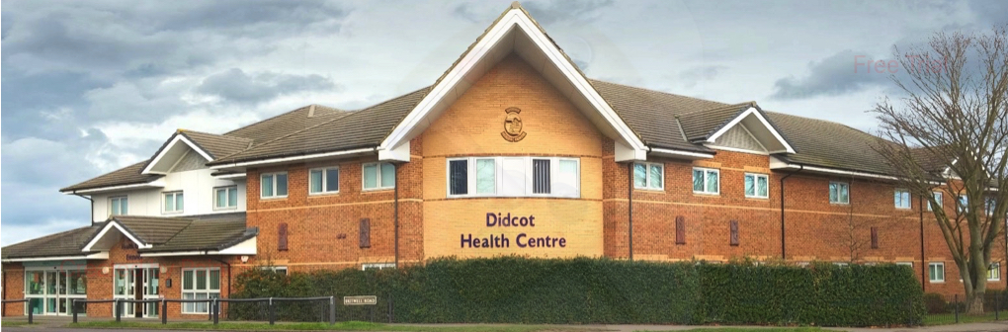

Didcot Health Centre

Partner or Salaried GP, South Oxfordshire

To start: Summer 2026 (negotiable) - five sessions or more per week
Situated at the heart of our community, we are a large, friendly team with forty years’ experience as a training practice. We are looking for a partner or salaried GP to join us for five or more sessions per week, ideally starting summer 2026.

About the job
The post covers the full range of duties and responsibilities associated with a GP working in primary care. In addition, we provide:
- Very competitive earnings
- Regular protected admin sessions
- Planned morning coffee breaks (and a staff coffee club!)
- Six weeks’ annual leave
- Up to one week’s study leave
- Mentoring while you find your feet
- Weekly MDT meetings.

About us
- Over forty years’ experience as a training practice (currently with two trainers)
- An EmisWeb/DocmanX GMS practice of 19,500 patients
- We have six partners and six salaried GPs supported by a strong paramedic, nursing, and PCN clinical team
- Rated ‘Good’ by CQC in all areas
- Supported by the Early Visiting Service for most home visits.

About you
- A fully qualified GP, eligible to work in General Practice in the NHS
- Motivated, enthusiastic, and looking for the support we can give to help you develop your chosen area of clinical interest.

Interested?
If you would like a short informal visit, please get in touch with us:

Jonathan Gayther
Practice Manager
jonathan.gayther@nhs.net
Gill Suter
Operational Practice Manager

g.suter@nhs.net

To apply, please send your CV to:

dhc.info@nhs.net
Didcot Health Centre
Britwell Road
Didcot OX11 7JH
www.didcothealthcentre.com

The closing date for applications is 30 April 2026, but we reserve the right to close applications early if we find the right candidate.

